EmpowerNet Installation Instructions for Version Updates

EmpowerNet Installation File Download
Empower Financials personnel will send you an email with a link that enables you to download the latest EmpowerNet version from our file sharing site.
Click the link in the email to be taken to our file sharing site. You will see the version numbered folder and the installation files in that folder.
Click on the download icon in the upper right of the screen to “Download all”.
Depending on your browser settings, the version numbered folder, contained in a .zip file, is either downloaded to your Downloads folder or to a folder specified by you.
Extract the version numbered folder from the zip file after downloading and put it into the Updates Folder specified under Settings – Locations in EmpowerSupport.
Once you’ve done that, your Updates Folder will look similar to this. You only need to keep Prerequisites and the latest and previous version folders in your Updates Folder.
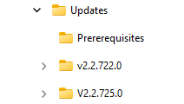

EmpowerWin Installation Instructions
EmpowerSupport is used to install new versions of the EmpowerWin application.
You can run EmpowerSupport from Start Menu All Programs EmpowerNET EmpowerSupport. EmpowerSupport must be run with administrator privileges. If you are running with User Account Control turned on, you will be prompted to allow the application to run as an administrator; click Yes.

Upgrade Databases
When EmpowerSupport opens, you will be on the Upgrade Databases tab.
- Select the database you want to upgrade
- Select the version you want to upgrade the database to. You will almost always be upgrading to the most recent version which will be the version shown by default.
- Click Backup.
- After backing up your database click Upgrade
If you prefer to run the scripts manually you can extract them to a file by clicking “Save to File.”
- If you have more than one database, be sure to upgrade each one.
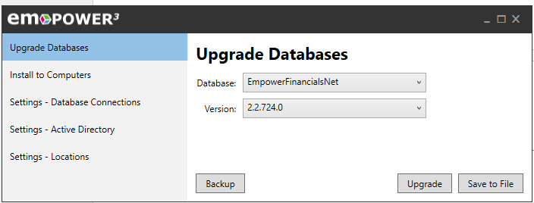

Install to Computers
The install to computers tab allows you to deploy the EmpowerWin application and the Crystal Reports runtime to computers on your network.
- Type a computer name in the computer(s) text box or multiple computers separated by a semi-colon
- Select the version of EmpowerWin
- Click Install
It’s not necessary to use EmpowerSupport to install EmpowerWin to each of your computers after upgrading your database. When the users next log into EmpowerWin, they will be told they need to upgrade their EmpowerWin version. If the Empower Support service is properly installed and running, the Empower Support service will push a new version of EmpowerWin out to their computer.
If you have a computer that runs the EmpowerService service, either to process EDI transactions or to send scheduled reports, be sure to install the latest version of EmpowerWin on that computer after upgrading your database. The EmpowerService runs EmpowerWin, and therefore needs the latest version of EmpowerWin installed.
If you get an error using EmpowerSupport to install EmpowerWin to the computers on your network or if your users get an error when they are told they need to upgrade their EmpowerWin version, you can manually install EmpowerWin on a computer following the instructions in the “Manually Install to Computers” section of this document.
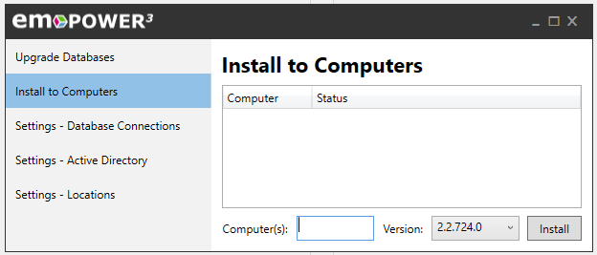

Manually Install to Computers
To install EmpowerWin manually on a computer
- Go to the Settings – Locations tab to find the name of your Updates Folder.
- Explore to the Updates Folder and then to the subfolder for the current version.
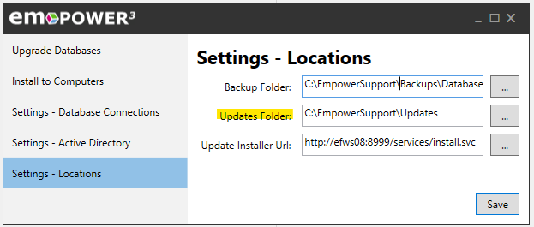
The Updates folder will contain a Prerequisites folder, as well as folders for each of the downloaded versions.
You can delete all but the most recent two version folders from this folder. The older versions are of no use.

To manually install Empower on a new computer, run Prerequisites.exe from the Prerequisites folder on that computer. That installs the necessary Crystal Reports runtime on the computer.
To install the latest EmpowerWin application on a new or existing computer, copy the Empower.config file from
C:\Program Files (x86)\EmpowerNET\2.0\EmpowerSupport
to
your Updates folder\v2.2.nnn.0, where nnn is the most recent version.
The v2.2.nnn.0 folder will then have the following files (as well as EmpowerWeb if you’ve licensed EmpowerWeb).
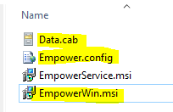
You’ll need the highlighted files to manually install EmpowerWin on a computer. Give the computer access to those files and run EmpowerWin.msi.

EmpowerWeb Installation
If you have an EmpowerWeb license, EmpowerWeb needs to be installed manually each time you upgrade your Empower database to a new version.
- Go to the Settings – Locations tab to find the name of your Updates Folder.
- Explore to the Updates Folder and then to the subfolder for the current version.
- Double-click on the EmpowerWeb.msi file in that subfolder to install EmpowerWeb.

